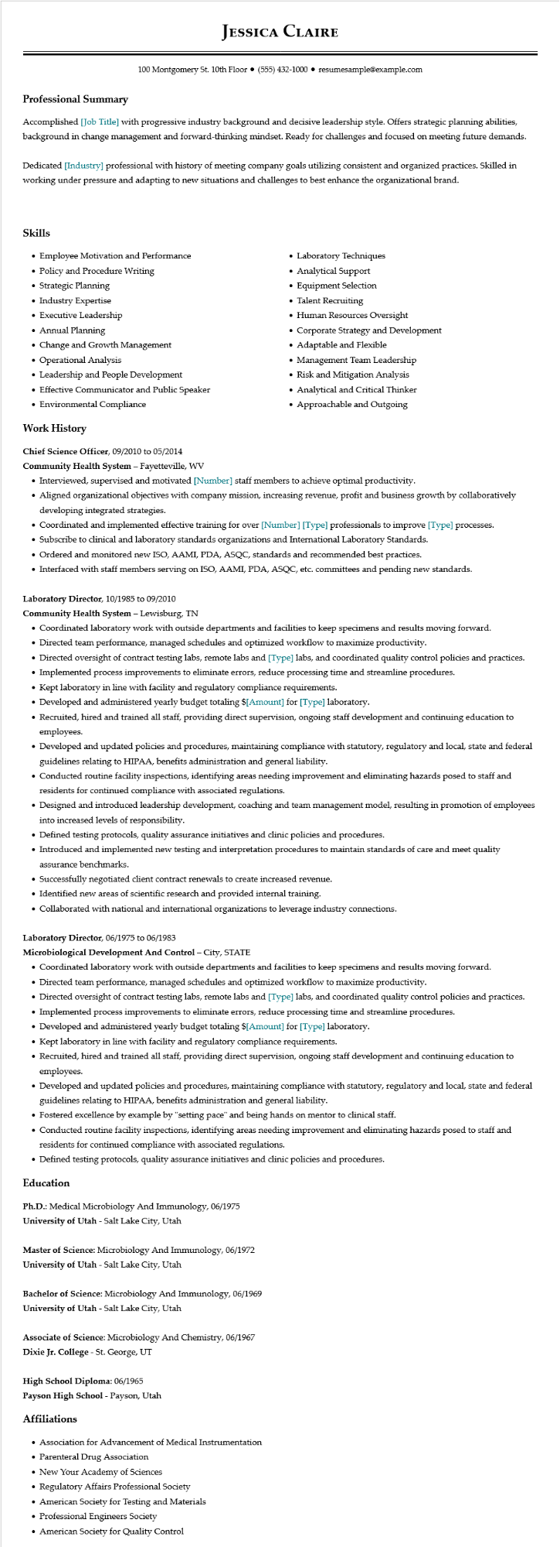
Professional Summary
JESSICA CLAIRE
100 Montgomery St. 10th Floor⚫ (555) 432-1000⚫ resumesample@example.com
Accomplished [Job Title] with progressive industry background and decisive leadership style. Offers strategic planning abilities, background in change management and forward-thinking mindset. Ready for challenges and focused on meeting future demands.
Dedicated [Industry] professional with history of meeting company goals utilizing consistent and organized practices. Skilled in working under pressure and adapting to new situations and challenges to best enhance the organizational brand.
Skills
• Employee Motivation and Performance
• Policy and Procedure Writing
• Strategic Planning
• Industry Expertise
• Executive Leadership
• Annual Planning
• Change and Growth Management
·
Operational Analysis
• Leadership and People Development
• Effective Communicator and Public Speaker
• Environmental Compliance
Work History
Chief Science Officer, 09/2010 to 05/2014
Community Health System - Fayetteville, WV
• Laboratory Techniques
• Analytical Support
•
Equipment Selection
• Talent Recruiting
• Human Resources Oversight
• Corporate Strategy and Development
• Adaptable and Flexible
.
Management Team Leadership
• Risk and Mitigation Analysis
• Analytical and Critical Thinker
• Approachable and Outgoing
• Interviewed, supervised and motivated [Number] staff members to achieve optimal productivity.
• Aligned organizational objectives with company mission, increasing revenue, profit and business growth by collaboratively developing integrated strategies.
• Coordinated and implemented effective training for over [Number] [Type] professionals to improve [Type] processes.
• Subscribe to clinical and laboratory standards organizations and International Laboratory Standards.
• Ordered and monitored new ISO, AAMI, PDA, ASQC, standards and recommended best practices.
• Interfaced with staff members serving on ISO, AAMI, PDA, ASQC, etc. committees and pending new standards.
Laboratory Director, 10/1985 to 09/2010
Community Health System - Lewisburg, TN
• Coordinated laboratory work with outside departments and facilities to keep specimens and results moving forward.
• Directed team performance, managed schedules and optimized workflow to maximize productivity.
• Directed oversight of contract testing labs, remote labs and [Type] labs, and coordinated quality control policies and practices.
• Implemented process improvements to eliminate errors, reduce processing time and streamline procedures.
• Kept laboratory in line with facility and regulatory compliance requirements.
• Developed and administered yearly budget totaling $[Amount] for [Type] laboratory.
• Recruited, hired and trained all staff, providing direct supervision, ongoing staff development and continuing education to employees.
• Developed and updated policies and procedures, maintaining compliance with statutory, regulatory and local, state and federal guidelines relating to HIPAA, benefits administration and general liability.
• Conducted routine facility inspections, identifying areas needing improvement and eliminating hazards posed to staff and residents for continued compliance with associated regulations.
• Designed and introduced leadership development, coaching and team management model, resulting in promotion of employees into increased levels of responsibility.
• Defined testing protocols, quality assurance initiatives and clinic policies and procedures.
• Introduced and implemented new testing and interpretation procedures to maintain standards of care and meet quality assurance benchmarks.
• Successfully negotiated client contract renewals to create increased revenue.
• Identified new areas of scientific research and provided internal training.
• Collaborated with national and international organizations to leverage industry connections.
Laboratory Director, 06/1975 to 06/1983
Microbiological Development And Control - City, STATE
• Coordinated laboratory work with outside departments and facilities to keep specimens and results moving forward.
• Directed team performance, managed schedules and optimized workflow to maximize productivity.
• Directed oversight of contract testing labs, remote labs and [Type] labs, and coordinated quality control policies and practices.
• Implemented process improvements to eliminate errors, reduce processing time and streamline procedures.
• Developed and administered yearly budget totaling $[Amount] for [Type] laboratory.
• Kept laboratory in line with facility and regulatory compliance requirements.
• Recruited, hired and trained all staff, providing direct supervision, ongoing staff development and continuing education to employees.
• Developed and updated policies and procedures, maintaining compliance with statutory, regulatory and local, state and federal guidelines relating to HIPAA, benefits administration and general liability.
• Fostered excellence by example by "setting pace" and being hands on mentor to clinical staff.
• Conducted routine facility inspections, identifying areas needing improvement and eliminating hazards posed to staff and residents for continued compliance with associated regulations.
• Defined testing protocols, quality assurance initiatives and clinic policies and procedures.
Education
Ph.D.: Medical Microbiology And Immunology, 06/1975
University of Utah - Salt Lake City, Utah
Master of Science: Microbiology And Immunology, 06/1972
University of Utah - Salt Lake City, Utah
Bachelor of Science: Microbiology And Immunology, 06/1969 University of Utah - Salt Lake City, Utah
Associate of Science: Microbiology And Chemistry, 06/1967
Dixie Jr. College - St. George, UT
High School Diploma: 06/1965
Payson High School - Payson, Utah
Affiliations
• Association for Advancement of Medical Instrumentation
• Parenteral Drug Association
• New Your Academy of Sciences
• Regulatory Affairs Professional Society
• American Society for Testing and Materials
• Professional Engineers Society
• American Society for Quality Control

